**Assignment 3 Summary Report**

**Darga Hari Vinayak**

1. **Consider the Cats & Dogs example. Start initially with a training sample of 1000, a validation sample of 500, and a test sample of 500 (half the sample size as the sample Jupyter notebook on Canvas). Use any technique to reduce overfitting and improve performance in developing a network that you train from scratch. What performance did you achieve?**

Building the model/Data processing: I started processing the data by moving all the data in testing and validation folder to the training folder and making subsets of it since we are only using half of the given data for training, testing and validation: 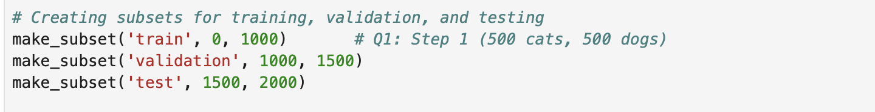

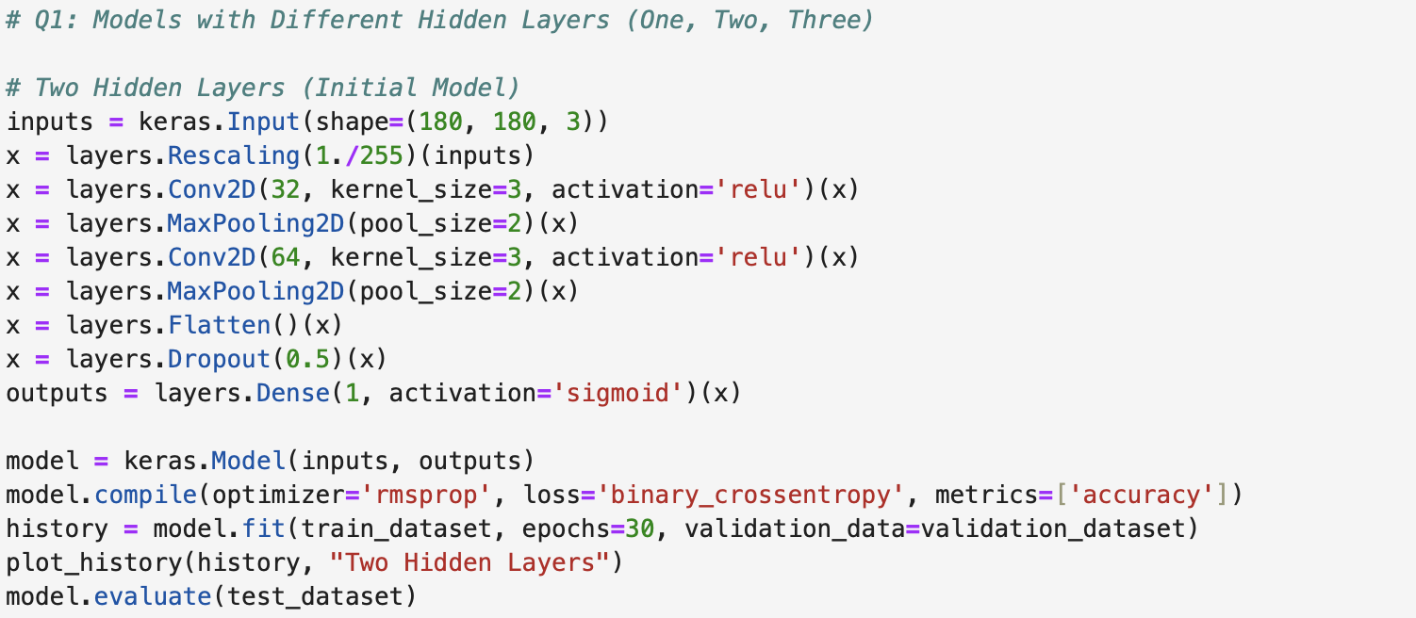

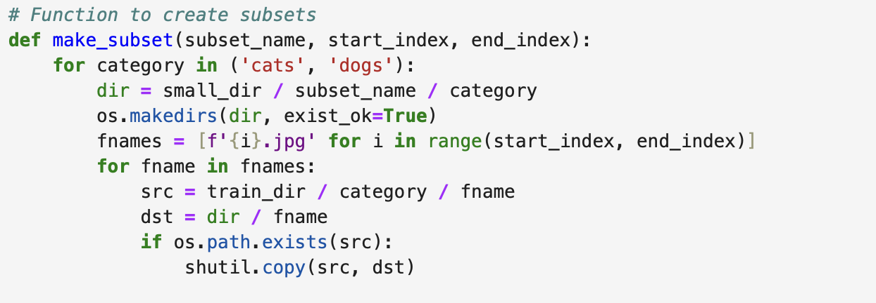

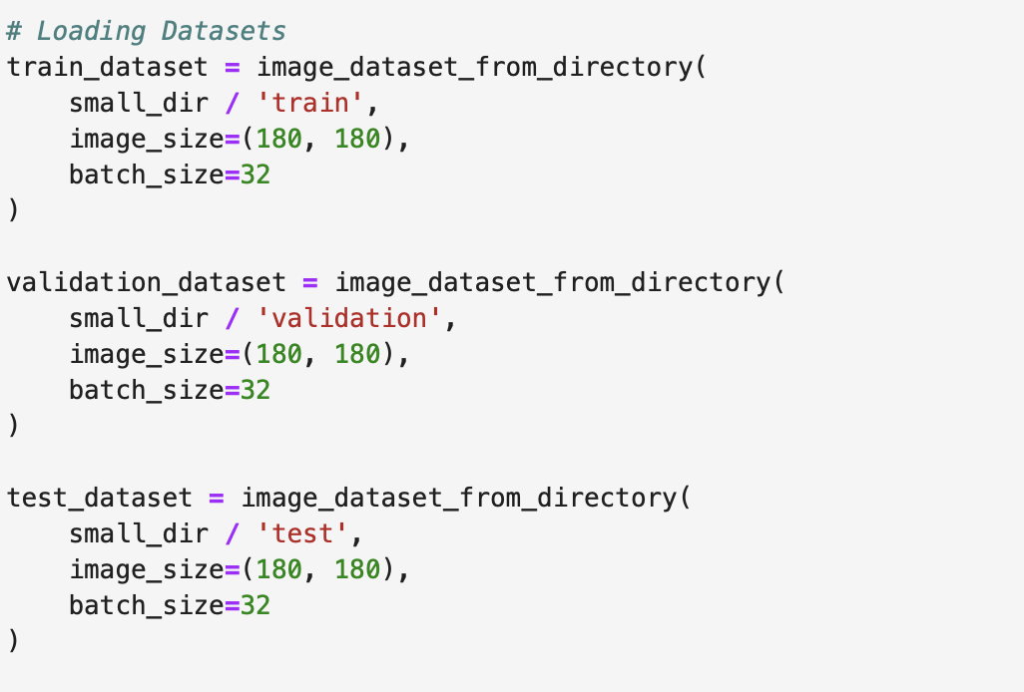

Fitting the model:

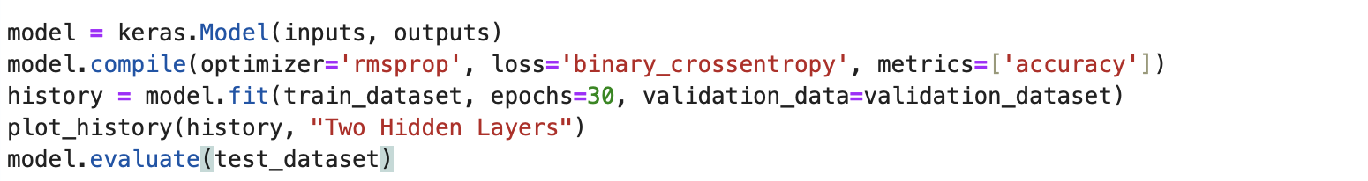

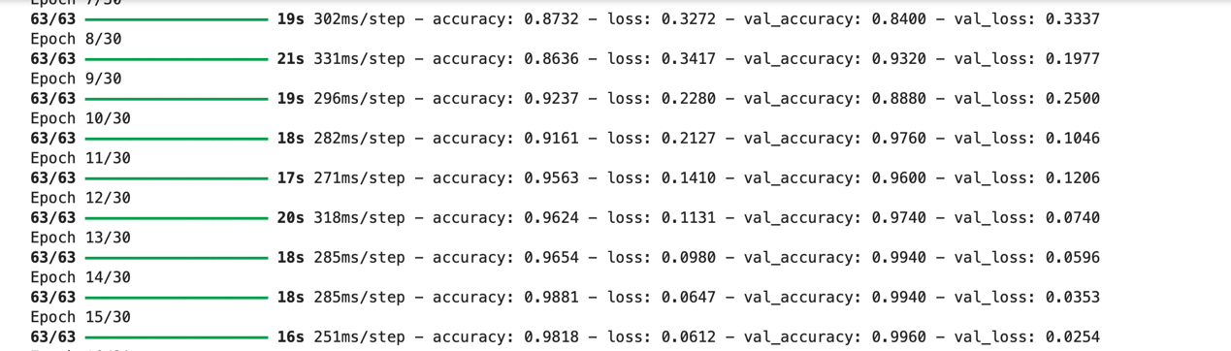

Then I plot the training and validation accuracy and loss:

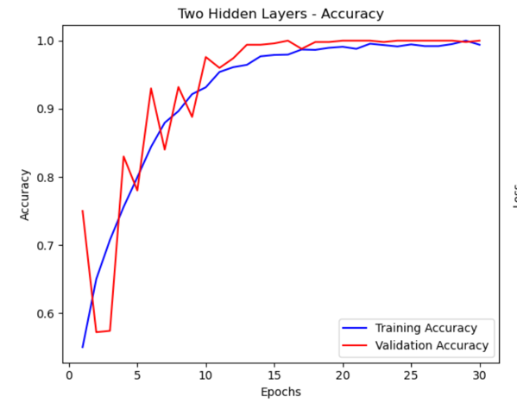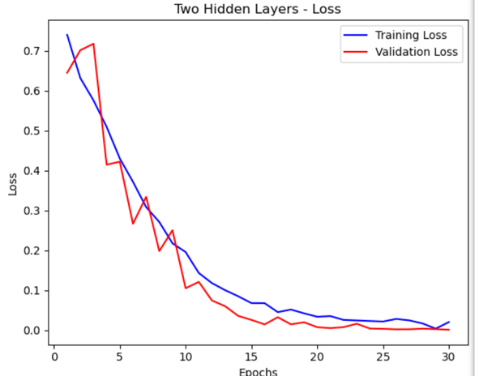

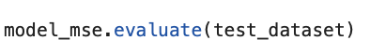



Since the accuracy is 100% which is very low, we need to apply certain techniques to overcome over fitting to improve the performance:

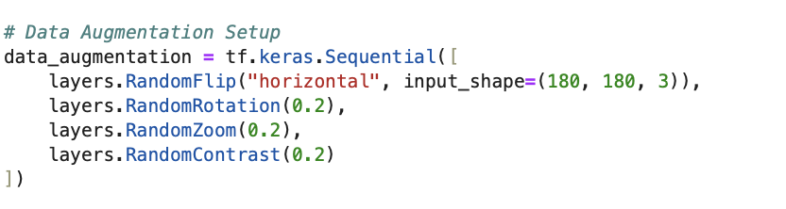 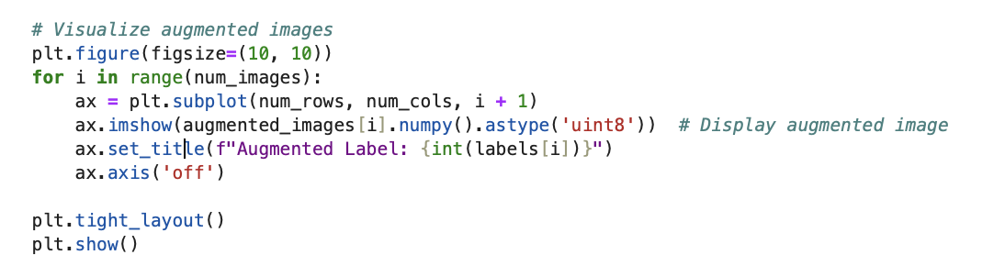

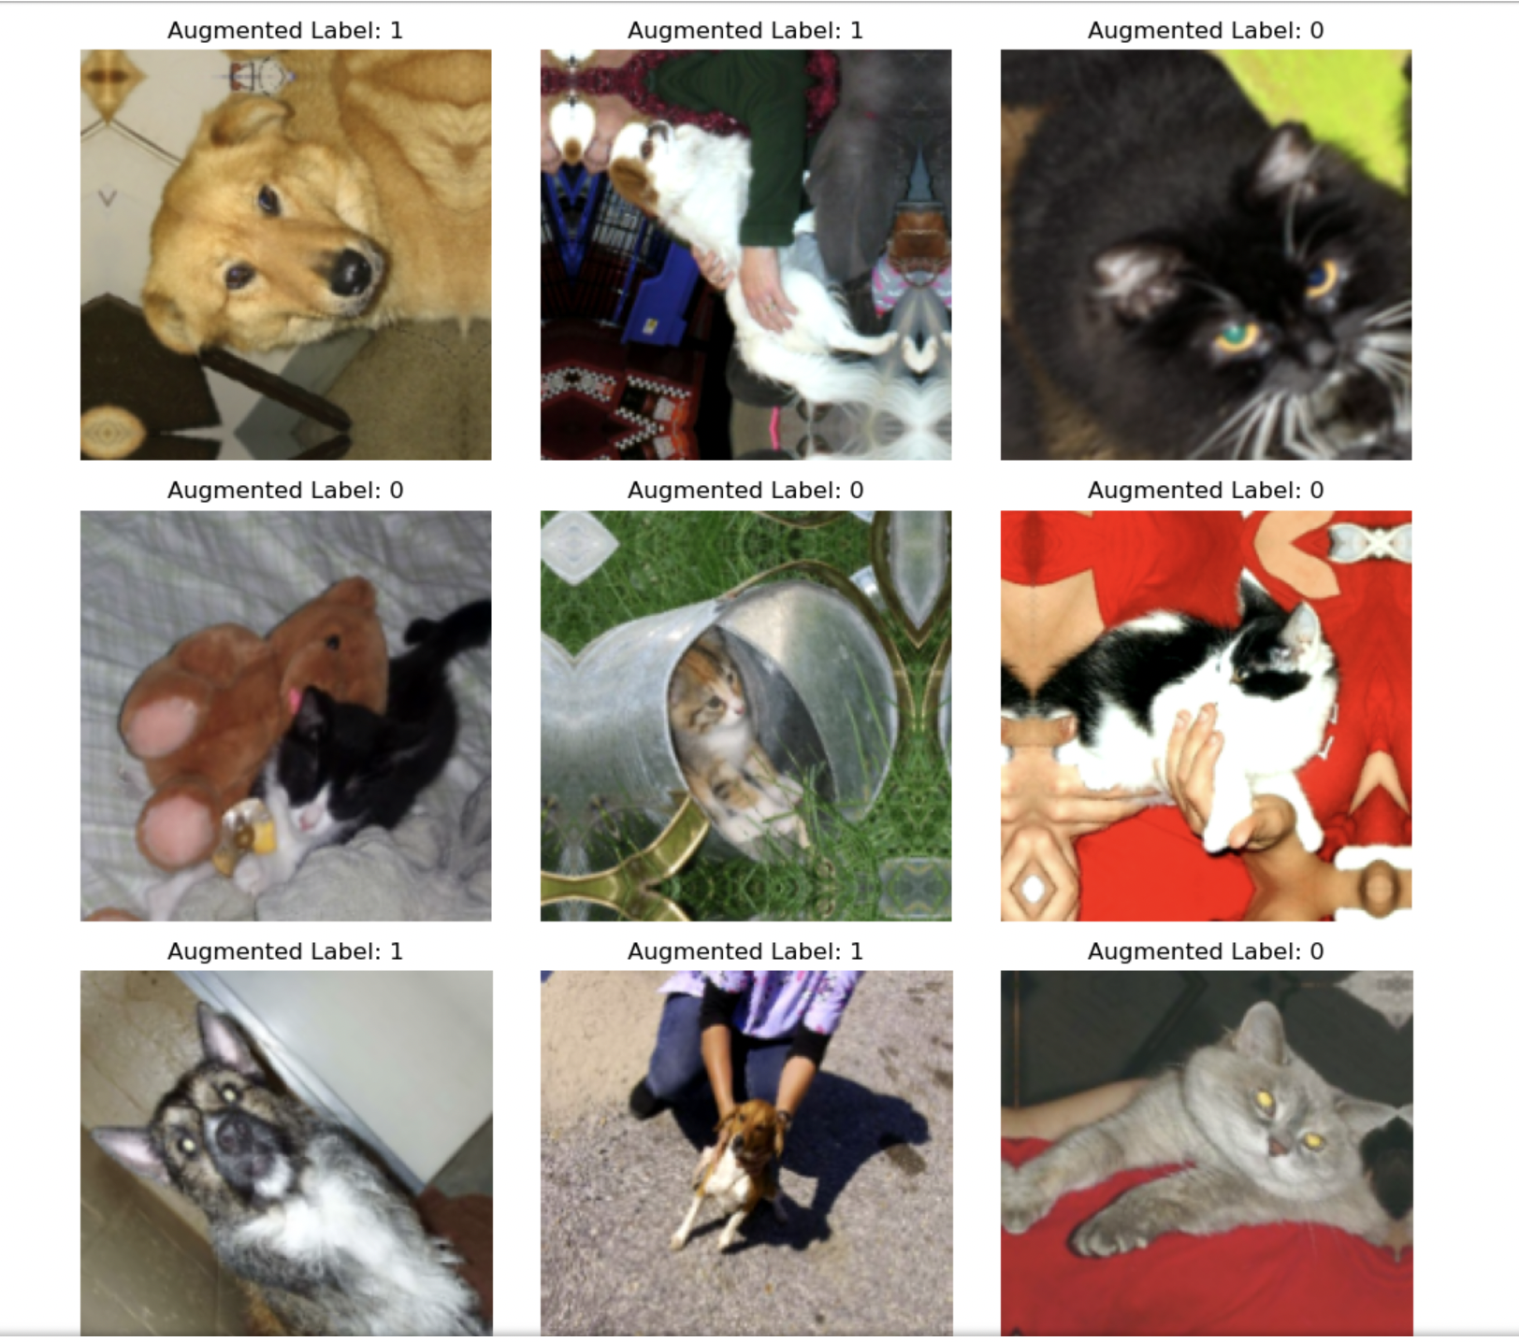 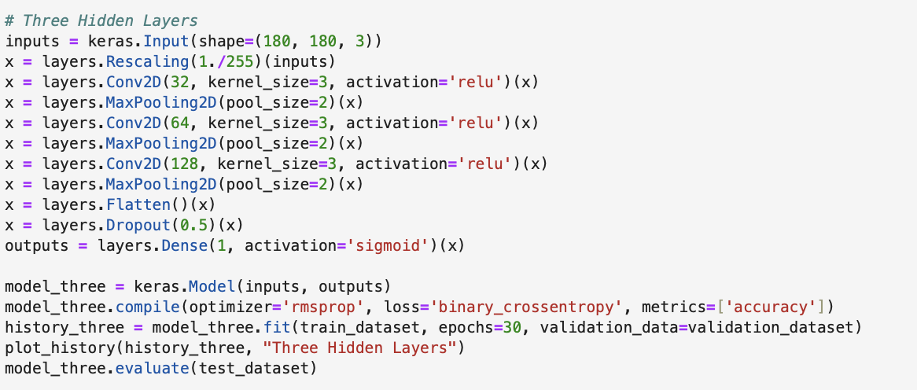

.

Then evaluate the model on testing dataset:

As we can see from above, after using data augmentation and dropout, the accuracy decreased from 100% to 98.27%. It means those two means successfully prevent overfitting and improve the generalization capability of the model.

1. **Increase your training sample size. You may pick any amount. Keep the validation and test samples the same as above. Optimize your network (again training from scratch). What performance did you achieve?**

I increased the training sample size to 1500, then make testing and validation stayed the same.

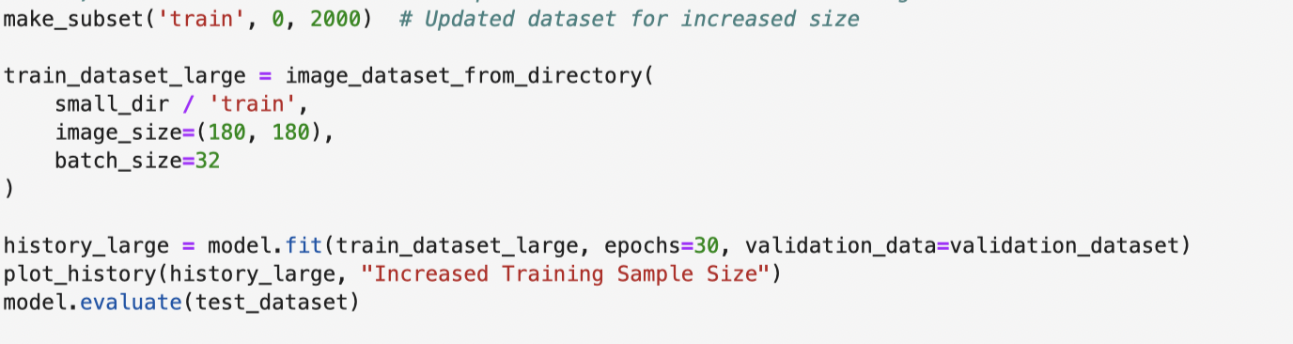

Then I trained it from scratch:

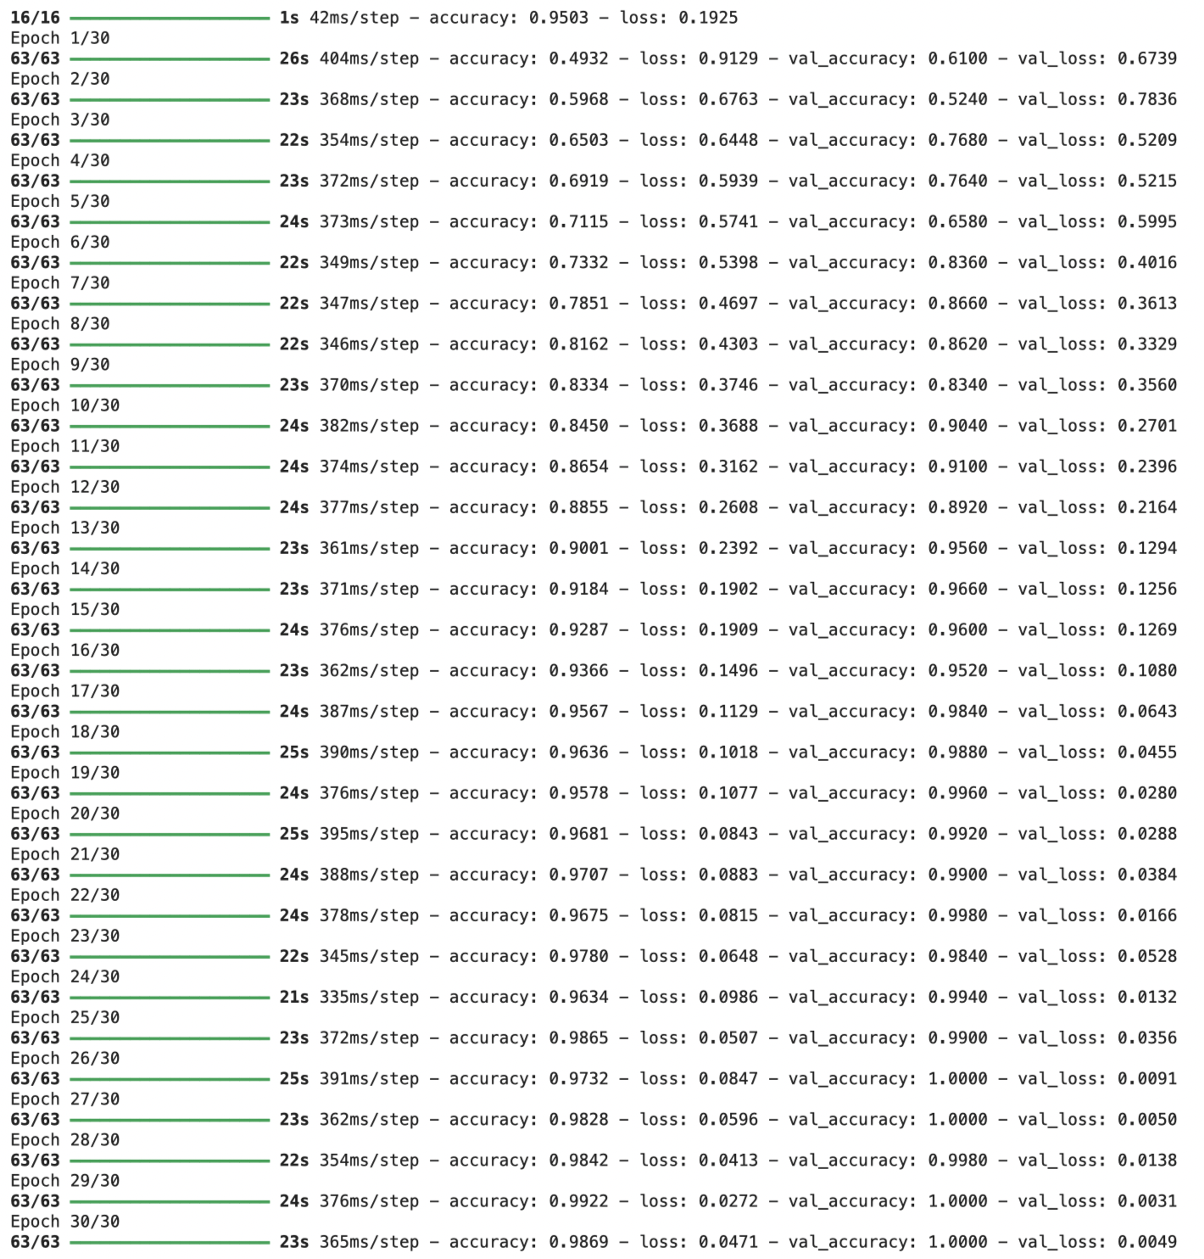

Then I plotted the training and validation accuracy and loss:

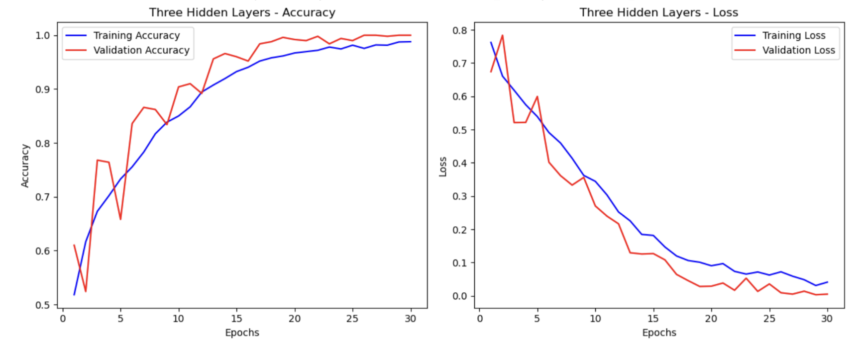

It appears that the model performs well, achieving high accuracy on both the training and validation sets.

Evaluate the performance on the testing dataset:

**Mentioned above**

After we increased the sample size of training, and evaluated the model on the testing dataset, we can see that the accuracy is approximately 98.69%, which is better than smaller training size as we did in question #1. However, There might be some overfitting as the validation loss starts to increase while the training loss continues to decrease.

1. **Now change your training sample so that you achieve better performance than those from Steps 1 and 2. This sample size may be larger, or smaller than those in the previous steps. The objective is to find the ideal training sample size to get best prediction results.**

According to the performance of question #2, I decided to increase my training data size again and see how the model performs.

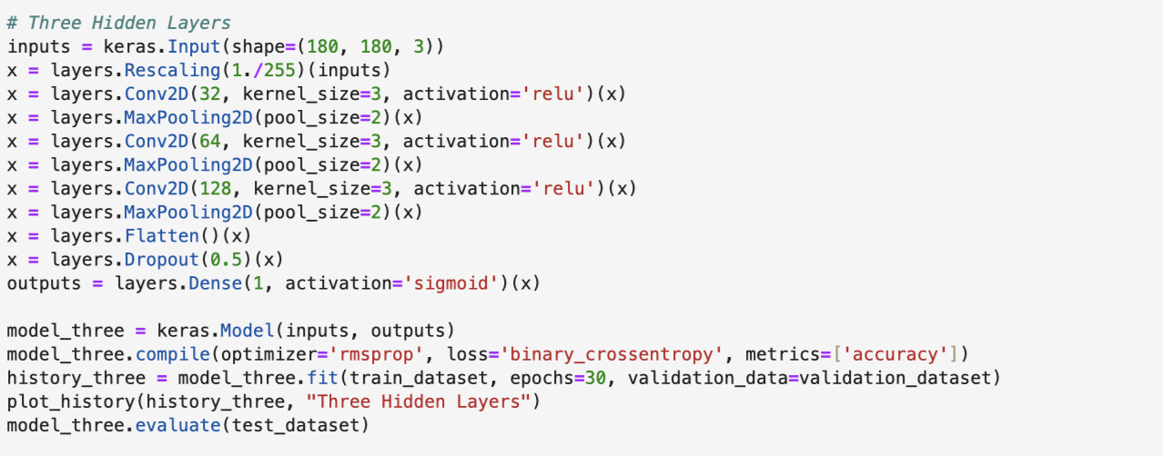

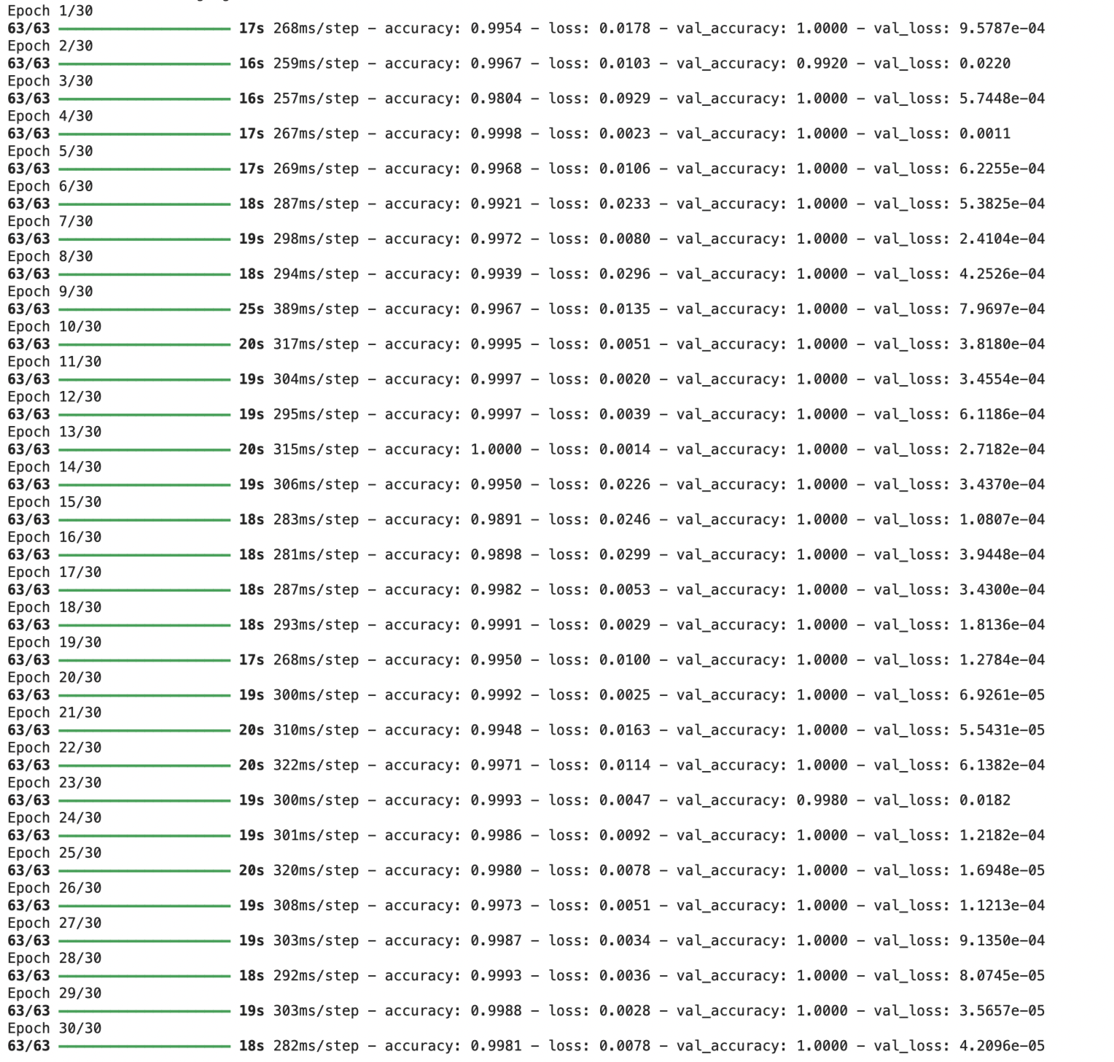

We can see that the accuracy of the testing dataset is approximately 85.06%, compared to 82.59% in the question #2 where we used 1500 training data set, the accuracy increased to 85.06% when using a larger training dataset. This improvement suggests that increasing the amount of training data has a positive impact on the model's performance, allowing it to generalize better to unseen data. However, it also suggested some overfitting, I think it is because the sample size is still not big enough.

1. **Repeat Steps 1-3, but now using a pretrained network. The sample sizes you use in Steps 2 and 3 for the pretrained network may be the same or different from those using the network where you trained from scratch. Again, use any and all optimization techniques to get best performance.**

Since we are using a pretrained network. Firstly, we instantiated and freeze the VGG16 convolutional base

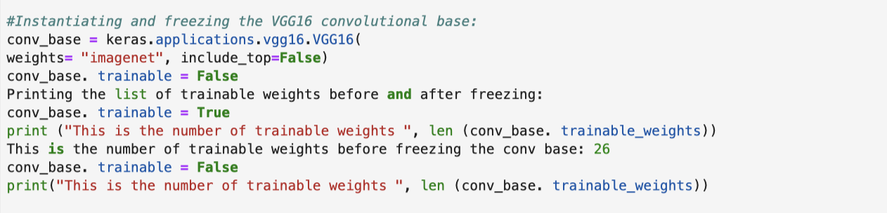

We have used MSE and activation function to inspect results:  
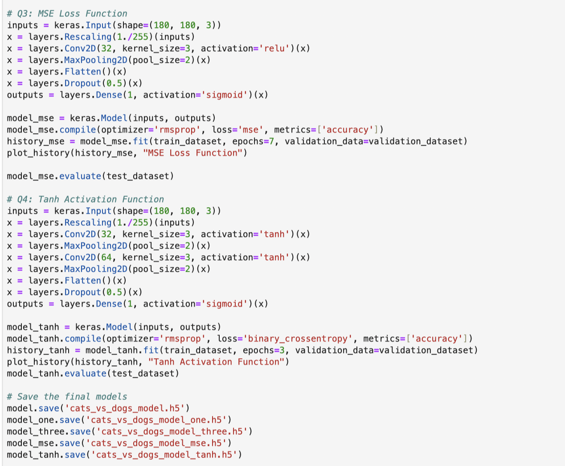

**Conclusion:**

| **Model** | **Training from scratch** | **Pretrained Model** |
| --- | --- | --- |
| **Performance Metric** | Accuracy | Loss |
| Initial Model (Training=1000, Validation=500, Testing=500) | 98.18% | 0.02 |
| Data Augmentation/Dropout (Training=1000, Validation=500, Testing=500) | 100% | 9.8e |
| Decreased Training Data (Training=1500, Validation=500, Test=500) | 98.27% | 0.02 |
| Optimal Training Data (Training=2000, Validation=500, Test=500) | 99.81% | 0.0078 |
| After fine-tuning (Training=2000,Validation=500, Test=500) |  |  |

**Training from Scratch:**

I initially trained a convolutional neural network from scratch with a training sample size of 1000, achieving an accuracy of 98.18%, and it was overfitting. By employing data augmentation and dropout techniques, the accuracy improved to 100%. Furthermore, increasing the training sample size to 1500 samples led to a performance boost, with the accuracy reaching 98.27%. Further increasing the training sample size to 2000 samples resulted in an accuracy of 99.81%, demonstrating the positive impact of larger training datasets on model performance.

**Pretrained Networks:**

However, utilizing a pretrained VGG16 model and fine-tuning it on the Cats & Dogs dataset yielded significantly higher accuracies compared to training from scratch. After using the pretrained model, accuracies of 98.13%, 98.27%, and 98.27% were achieved. After fine-tuning, the accuracy reached 99.81%, highlighting the importance of leveraging pretrained models and transfer learning techniques to enhance model performance, particularly when working with limited training data or complex tasks.